# Electrical System

## Overview

The electrical system is a crucial subsystem that provides power to other subsystems on the pod. The main objectives of the electrical system is to increase efficiency, improve reliability, minimize size and weight, and provide power supply to the pod while prioritizing safety from undesired conditions, and meeting relevant regulatory requirements and standards.

## Design

* The Electrical System consists of two parts, a High-Voltage System and a Low-Voltage system
* The High Voltage System provides power to the levitation units and traction system.
* The Low Voltage system is used to power the onboard electronics, telemetry and data transmission systems.
* The Low Voltage and High Voltage Systems are electrically isolated to ensure safety and minimize noise in the low power system
* The Low voltage system is also used for providing auxiliary power to components present in the High Voltage System.

Last point aur 3rd

## The High Voltage System

The High Voltage System consists of,

* A high power battery pack
* BMS for managing the high-power battery pack.
* Inverters for converting DC to three-phase AC in order to provide power to the traction system.
* Levitation Power Units which deliver a constant current to the EMS based on the PID control signal.
* Switchgear for Safety and Protection of the Power Electronics and the Battery Pack.

## 3.1. HV System Diagram

The basic block diagram of the High Voltage System is shown below:

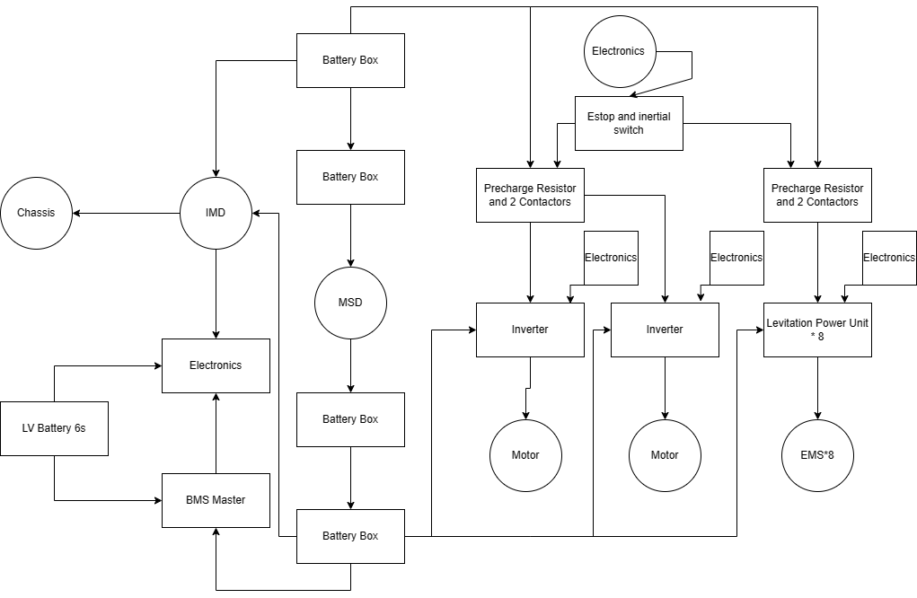

## 3.2. Battery Pack

* The system uses 8 of Tattu’s 6S 12Ah Li-Po batteries in series.
* The pack is distributed into 4 “battery boxes”, each containing two of the batteries in series along with basic protection circuitry such as a fuse and a contactor.
* The “battery box” has a basic diagram that is represented below:

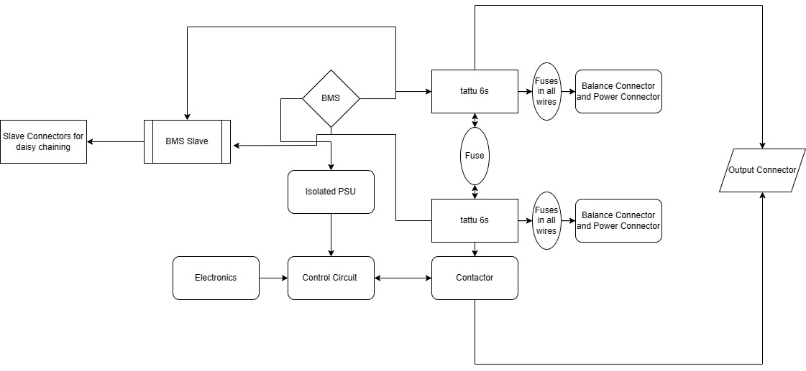

* The specs of the High Voltage battery are:-

| Battery type | Li-Po |
| --- | --- |
| Capacity[Ah] | 12 |
| Nominal Voltage [V] | 177 |
| Cell Configuration | 48S1P |
| Max. Discharge Current[A] | 360 |
| Weight[Kg] | 15Kg (Approx.) |
| Dimensions[mm x mm x mm] | 300 x 90 x 120 (each battery box) |

## 3.3. Battery Management System

A battery management system with a master-slave architecture will be used as represented in the diagrams. The slave modules (monitoring modules) will be placed in the battery boxes while the master module will be placed outside the battery with connections to the slave modules. The slave modules will each monitor and balance 12 cells (i.e 2 of the 6S batteries) each and hence, four such modules will be daisy chained. The master will collect battery voltage and temperature data and also provide overcurrent protection, and overcharge protection.

## 3.4. Power Electronics

Levitation Power Units: They provide a constant current source required for powering up the EMSes. The specs for Lev. Power Units are below:-

| Input Voltage Range[V dc] | 100-400 |
| --- | --- |
| Output Voltage Range [V dc] | 0-350 |
| Constant Current Range [A] | 0-30 |
| Current Correction Frequency [KHz] | 5 |

Inverter Units: The Inverters are used to provide a 3 phase AC power supply for the traction system from the DC battery pack. The specs for Inverter Units are below:-

| Input Voltage Range[V dc] | 100-400 |
| --- | --- |
| Current [Phase Current A] | 300 |
| Power Output [W] (at Vin=177V) | >50kW |

## The Low Voltage System

The low voltage system is used to provide power to the sense and control subsystem. Also, it provides auxiliary power to the BMS for HV System and power electronics.

The system consists of a battery, fuse and a BMS.

4.1 The Battery

The specs of the battery are:-

| Battery type | Li-Po |
| --- | --- |
| Capacity[Ah] | 5.2 |
| Nominal Voltage [V] | 22.2 |
| Cell Configuration | 6S1P |
| Max. Discharge Current[A] | 130 |

4.2 BMS

A BMS is also used for the LV battery which monitors it for overcurrent, overcharge, over discharge and also allows for balanced charging of the battery. The temperature of the LV battery is also monitored.

## Testing

Both the battery systems will be tested at the rated loads for functionality. Also, both the systems will be tested for fault conditions such as overcurrent/short circuits, over charging, and also over voltages. The systems will be ensured to be safe under all conditions.